New York Soccer Club

MLS Next Boys 2007

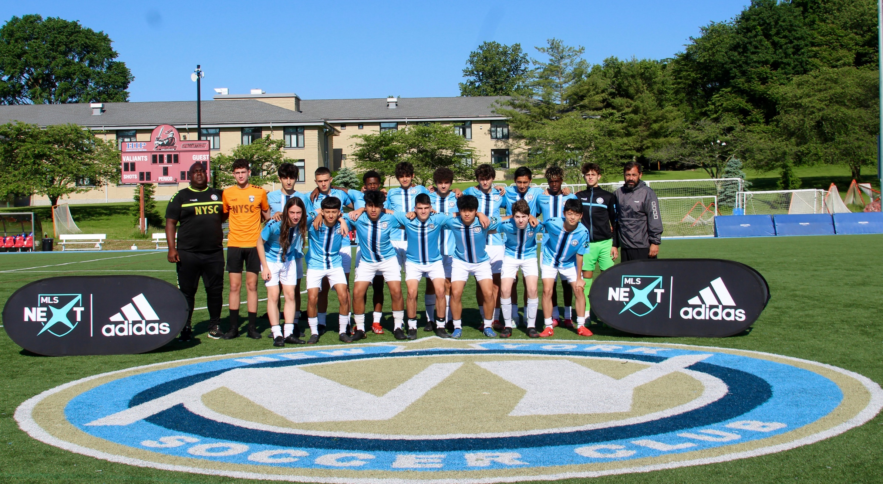

 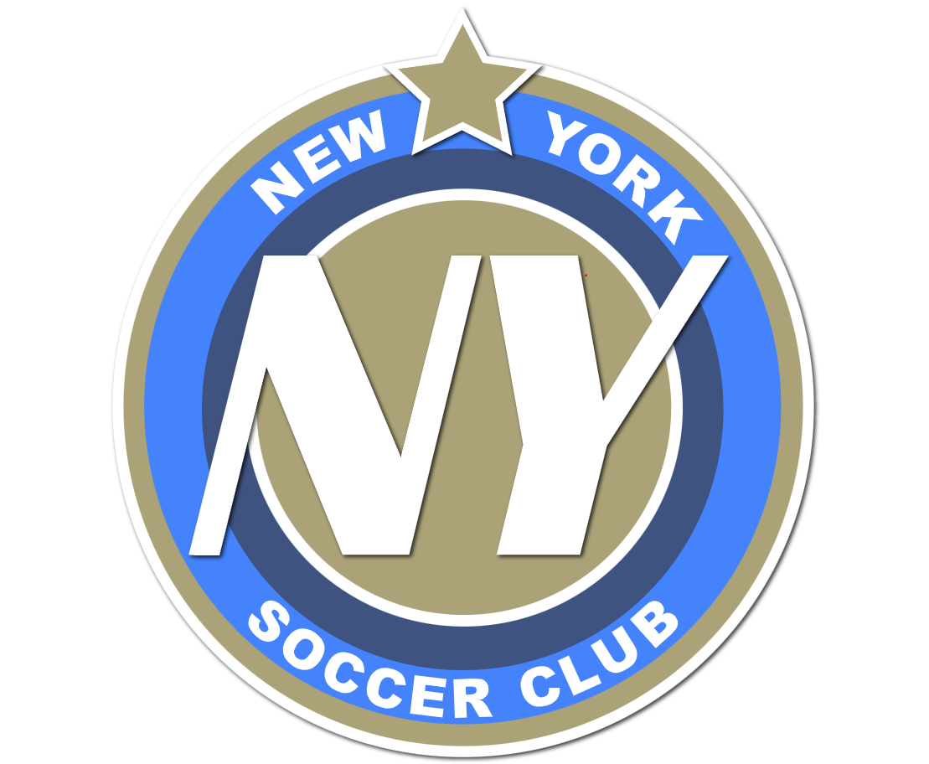 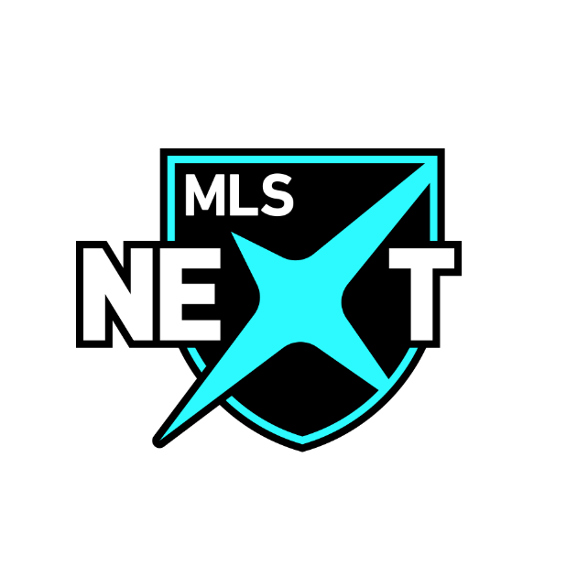

1st Team in New York Soccer Club (NYSC) history

to reach the playoffs in the top division

Dedicated to Coach Christian who tirelessly imparted the NYSC values of Teamwork, Respect, Excellence, Ambition, and Effort while teaching us the joys of “the Beautiful Game”.

Head Coach Christian Gonzalez Assistant Coach Paul Brooks (Brooksie)

Johan Bermudez Cameron Brooks Kane Christian Tomo Sabatello-Chalfen David Dolorez

Christopher Gonzalez Hayato Kobayashi Zachary Maad Erick Monge Jelique Panton

Giovanni Porrini-Fernandez Nicola Rana Dylan Randazzo Brandt Robbins Felix Samson

Yusuke Sato Frank Torres